4 Spatial exploratory analysis of Chicago crime incident data

4.1 Data Preprocessing and Feature Transformation

Urban crime exhibits significant spatial heterogeneity, often manifesting as hotspots and clustering phenomena. For subsequent crime forecasting, police resource allocation, and risk warning, identifying spatial hotspots, understanding their stability, and recognizing spatial variations across different crime scenarios are critical steps. Therefore, this part requires spatial exploratory data analysis (EDA) to provide an overview of the data's spatial structure and to extract spatial patterns and feature design directions applicable for modeling.

4.2 Spatial Distribution and Hotspots
Crime hotspots and low-ICE (more impoverished/resource-deprived) census tracts show significant overlap in the southern and western urban areas—these zones cluster more prominently in the negative value range on the ICE map (Figure 4.2.1), while your crime hexbin displays higher density bands in corresponding locations (Figure 4.2.2). In contrast, the northern/lakeside areas (where ICE values are higher and more affluent) exhibit weaker overall crime density, though it is not entirely absent.
4.3 Administrative divisions with high incidence rates
Aggregating case volumes across two administrative scales—District and Community Area—and identifying the Top 10. At the District level, high incidence rates resemble a "multiple districts in parallel" pattern, with no single area exhibiting extreme dominance (Figure 4.3.1); At the Community Area level, the top positions are more concentrated, with a few areas significantly exceeding others, indicating clearer hotspots at finer granularity (Figure 4.3.1).
4.4 Heterogeneity of layered spaces
To examine whether hotspots vary according to crime type and location context, we stratified the data by Primary Type (THEFT / BATTERY / ROBBERY) and Location_Group (STREET / APARTMENT / RESIDENCE), plotting hexbin density maps for each subset for comparison. Results indicate that hotspot distributions for different crime types do not fully overlap: THEFT exhibits higher densities concentrated in high-activity zones within central urban areas and along lakeshores, demonstrating a more pronounced "core clustering" (Figure 4.4.1). BATTERY hotspots tend towards multiple community-based clusters, appearing spatially dispersed and multi-centred (Figure 4.4.2). ROBBERY coverage is relatively smaller, concentrated in fewer localised areas (Figure 4.4.3).
4.5 Grid-based hotspots and annual persistence
After grid-based statistical analysis of latitude and longitude data at 0.01° intervals, a distinct spatial pattern emerged: a "centralised core with multiple hotspot clusters". A small number of adjacent grid cells (e.g., approximately -87.63, 41.87–41.90) consistently occupied the highest-frequency hotspots (Figure 4.5.1). Year-on-year comparisons revealed that core hotspot locations remained broadly stable, while intensity fluctuated annually and exhibited minor drift between neighbouring grids (Figure 4.5.2).
References
[1] A. J. Weiss, M. Reina, N. Matoba, N. Prachand, and J. W. Collins Jr., “The Relation of Neighborhood Racial and Income Polarity to Preterm Birth Rates in Chicago,” Maternal and Child Health Journal, early access, 2023, doi: 10.1007/s10995-023-03608-5.

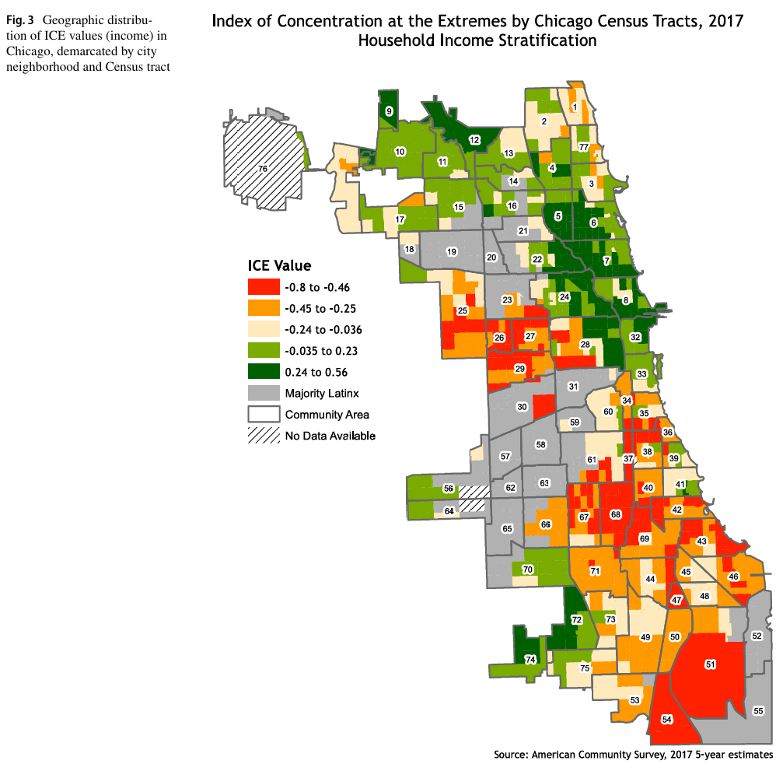

Figure 4.2.1 Index of Concentration at the Extremes by Chicago Census Tracts,2017

Household Income Stratification [1]
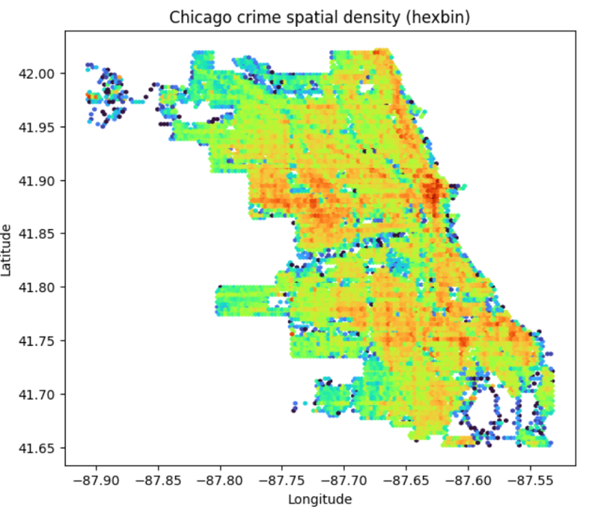

Figure 4.2.2 2015–2024 Chicago Crime Spatial Density Heatmap
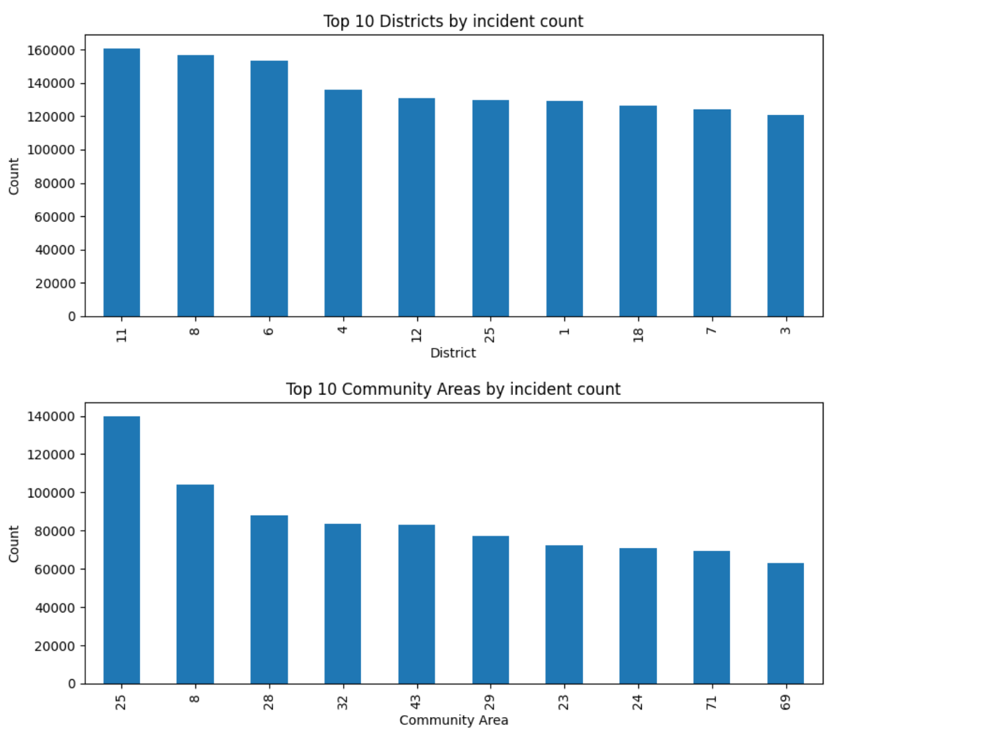

Figure 4.3.1 Top 10 Districts and Community Areas Crime Incident Comparison (2015–2024)
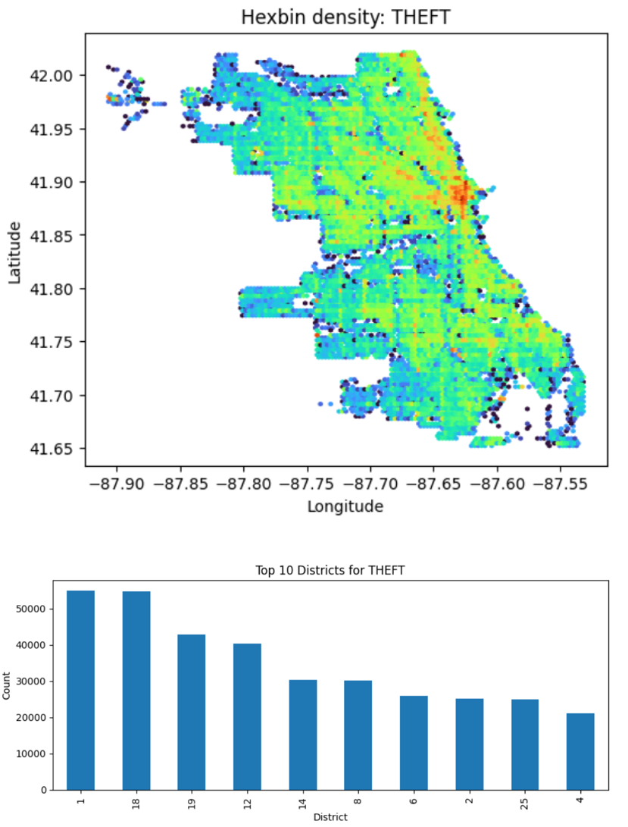

Figure 4.4.1 Theft Hotspots and Top Districts (2015–2024)
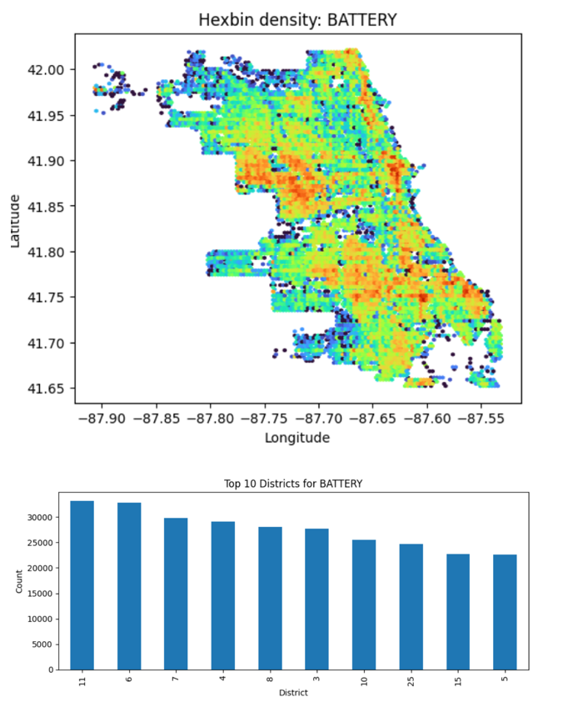

Figure 4.4.2 Battery Hotspots and Top Districts (2015–2024)
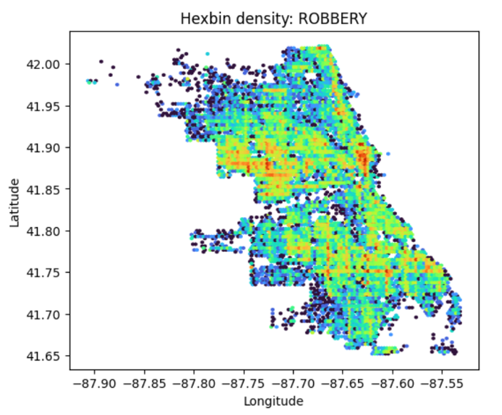

Figure 4.4.3 Chicago Robbery Incident Hotspots (Hexbin Map)

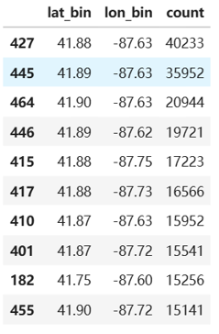

Figure 4.5.1 Top 10 Spatial Grid Hotspots (0.01° Binning)

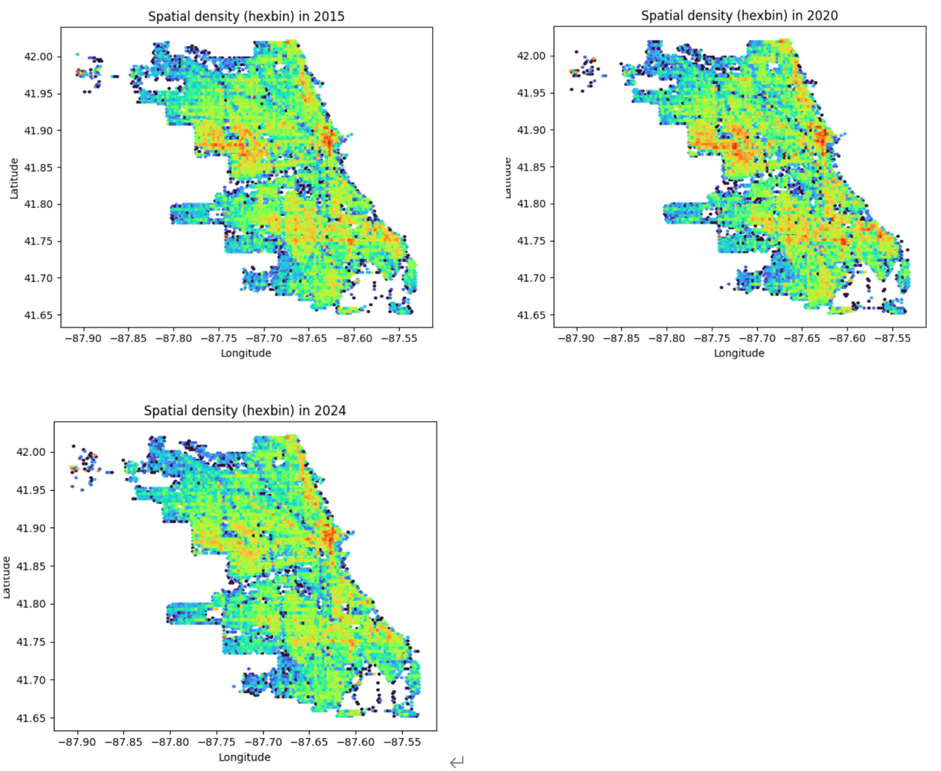

Figure 4.5.2 Spatiotemporal Variation in Incident Density in Chicago (Hexbin), 2015/2020/2024

